**Assisted Practice: 3.4 Event Binding**

This section will guide you to:

* Implement event binding

This lab has two section that is :

3.4.1 Implementing event binding

3.4.2 Pushing the code to Github repositories

**Step 3.4.1:** Implementing event binding

* Open Visual Studio Code
* Call *toggleImage()* when any button is clicked in *Product-list.component.html*.
* Add the following code in *Product-list.component.ts*.

export class ProductListComponent{

pageTitle: string = "Product List Page";

imageWidth:number = 80;

imageMargin:number = 10;

showImage:boolean = false;

toggleImage() : void {

this.showImage = !this.showImage;

// (!false = true) // (!true == false)

console.log('Value of ShowImage inside function ::', this.showImage);

}

}

* Add the following code in *Product-list.component.html.*

<button class="btn btn-primary" (click)='toggleImage()'>

Show Image

</button>

**Output:**

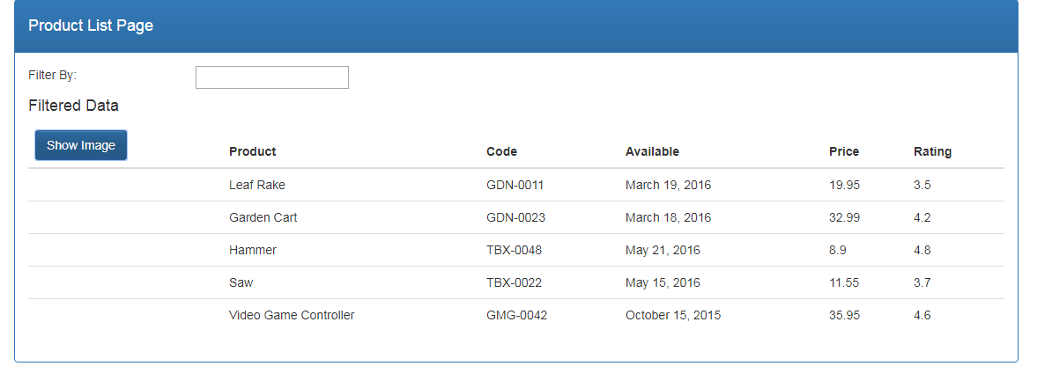

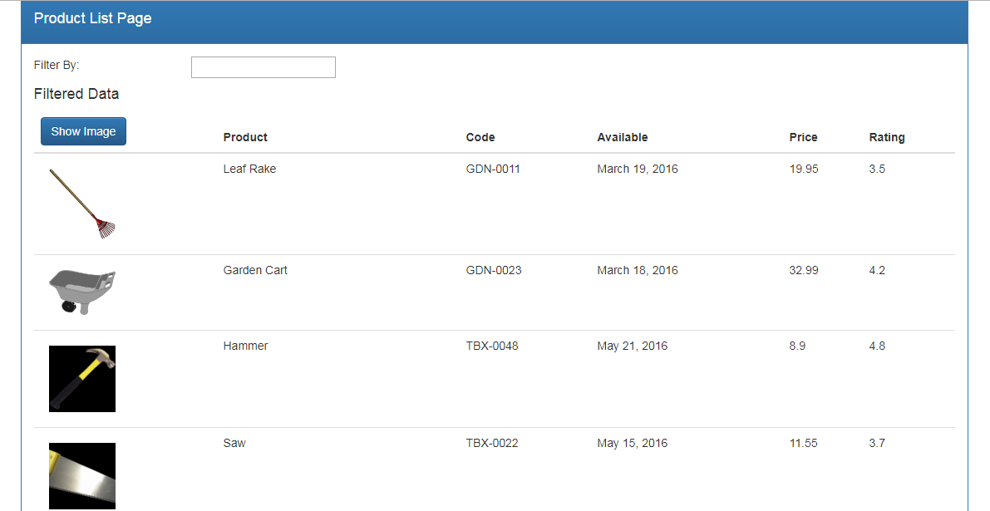

**Step 3.4.2:** Pushing the code to your GitHub repositories

* Open your command prompt and navigate to the folder where you have created your files.

**cd <folder path>**

* Initialize your repository using the following command:

**git init**

* Add all the files to your git repository using the following command:

**git add .**

* Commit the changes using the following command:

**git commit . -m “Changes have been committed.”**

* Push the files to the folder you initially created using the following command:

**git push -u origin master**